Cloning a Remote GitHub Repository SOP



Table of Contents

1. Cloning a Remote GitHub Repository 3
1.1 Description 3
1.2 Architecture Diagram 3
1.3 Lab Steps 4
1.4 Troubleshooting 4
1.5 Supporting References 5

Cloning a Remote GitHub Repository

Description
In this lab, we have been called into a situation where we need to clone a remote GitHub repository for a new developer. We have got an AWS Linux server and we will need to setup that to work on, and at last we will create a local copy of the GitHub repository.

Architecture Diagram
The diagram below displays a visual representation of the application architecture:
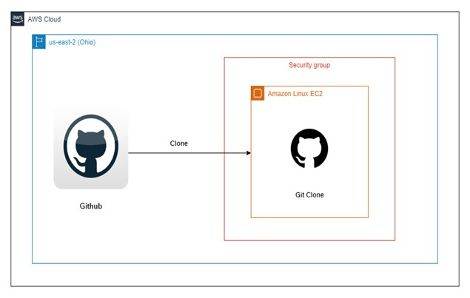

Lab Steps
Follow the steps outlined below to achieve the objective of this lab exercise:

- Create an EC2 Instance with following configuration:
  - Choose Amazon Linux 2 AMI with 64-bit (x86).
  - Choose t2. micro as an instance type.
  - Leave the configure instance details with their default values.
  - Leave the add storage section as default.
Note: If you want more volume you can increase the volume in that section.
  - In this step add key as Name and in value section specify a name such as example for your EC2 Instance.
  - Configure Security group with SSH (Port 22) to your group.
  - Review the complete configuration.
  - Create a new key pair and download it in your PC before launching.
  - Launch the EC2 Instance.
- SSH into your EC2 Instance using your command prompt or PuTTY:
- Enter the following code in the Powershell:
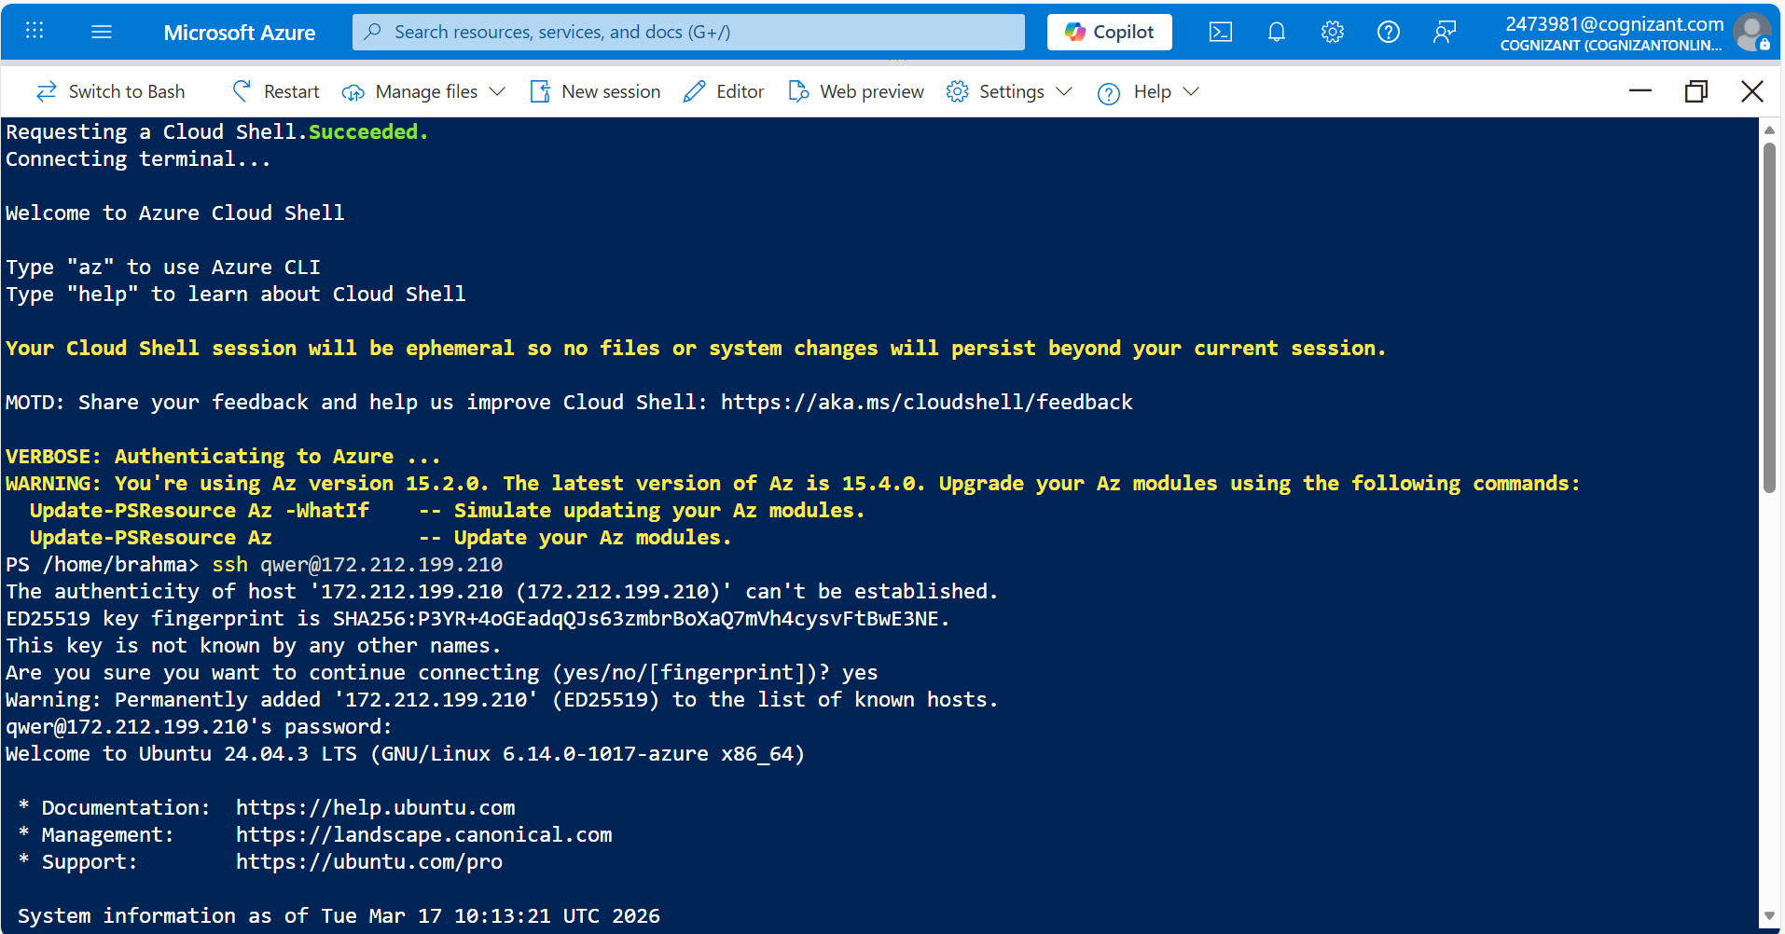
ssh -i <.ppk file location> ec2-user@<public ip>

Note: .ppk file location is address where you have kept your Key that is required to connect with your EC2 instance. Public IP is the IP address of the EC2 Instance. Replace it with your EC2 Instance IP address.
- Install GIT by using the following command:
sudo yum install git
- Configure your GitHub with git (optional):
git config –global user.name “yourusername” git config –global user.email “eg_youremail”
- Create Local Repository Location with the following command:
mkdir gitwork cd gitwork
- Clone the Remote Repository to the Local Location:
• Open your GitHub repository and therein copy the URL that is given in Download or Clone Box.
- Clone it by using git clone command. GitHub repository is thus successfully cloned to local repository location:
git clone https://github.com/aws/aws-elastic-beanstalk-cli-setup
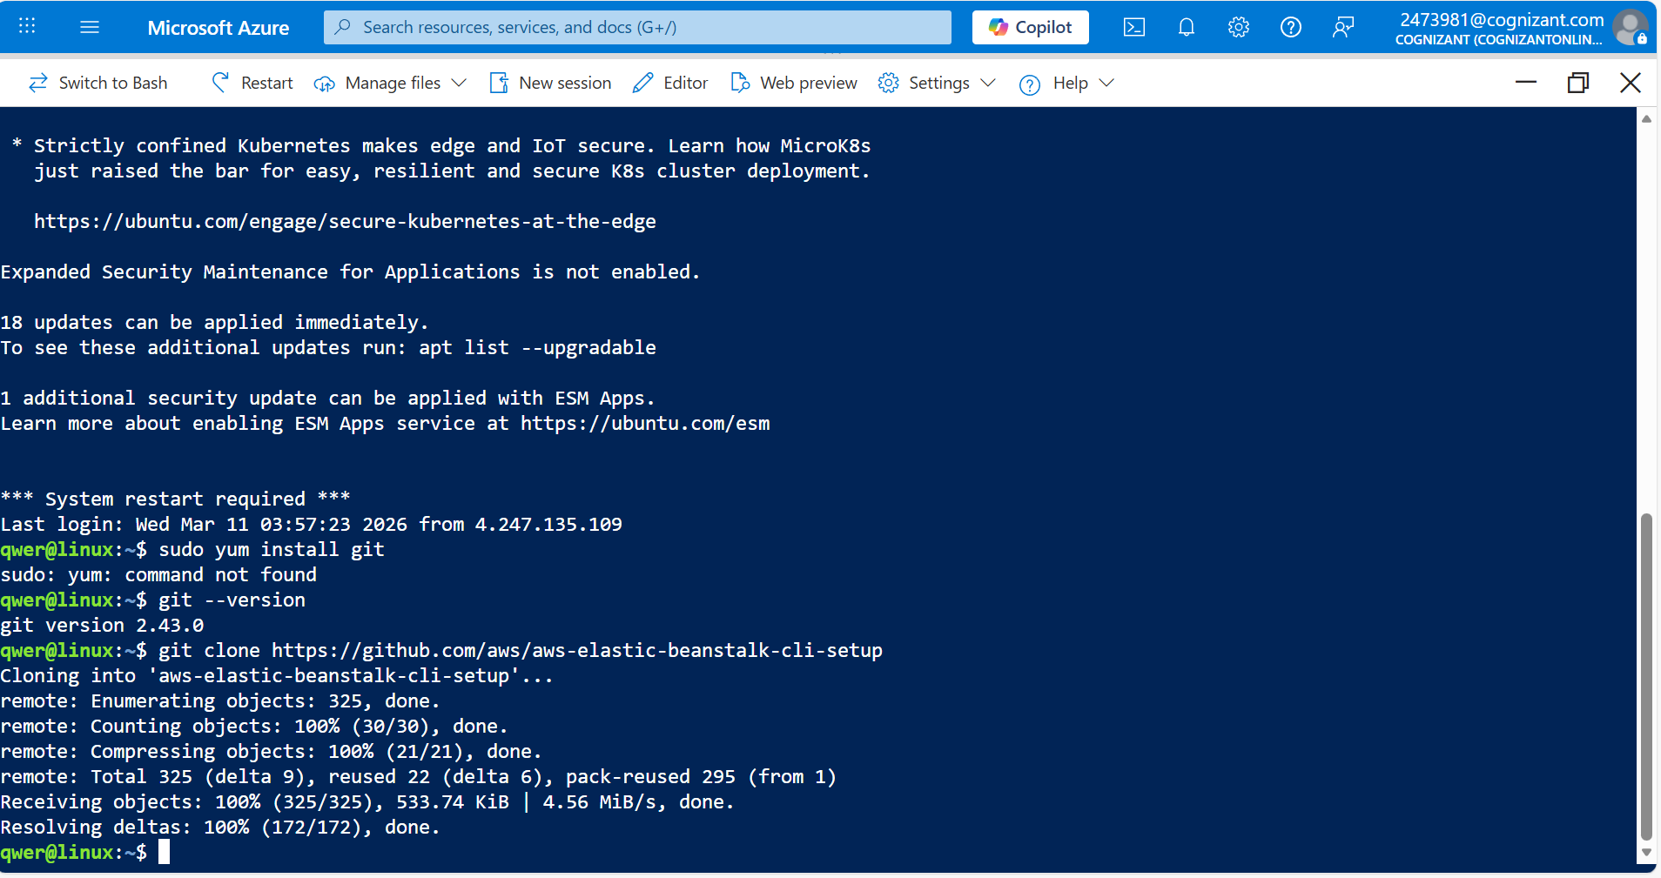

Troubleshooting
S. No | Problem | Solution
1 | Cannot connect local to remote repository. | Firstly, check that the repository on GitHub is not private. Moreover, use https for connection.

Supporting References
Refer the below links for additional information:

- https://product.hubspot.com/blog/git-and-github-tutorial-for-beginners
- https://www.vogella.com/tutorials/Git/article.html

